In this video we will discuss **implementing login page for ASP.NET Web API**. This is continuation to [Part 23](http://csharp-video-tutorials.blogspot.com/2016/12/using-fiddler-to-test-aspnet-web-api.html). Please watch [Part 23](http://csharp-video-tutorials.blogspot.com/2016/12/using-fiddler-to-test-aspnet-web-api.html) from [ASP.NET Web API tutorial](https://www.youtube.com/playlist?list=PL6n9fhu94yhW7yoUOGNOfHurUE6bpOO2b) before proceeding.  
  
We want to design a login page that looks as shown below   
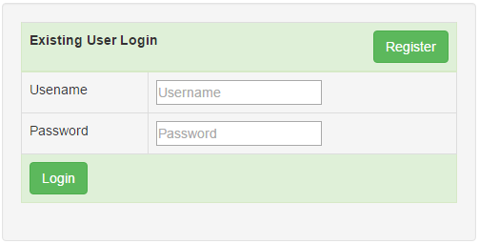   
  
  
  
If we provide invalid username and password the error should be displayed as shown below   
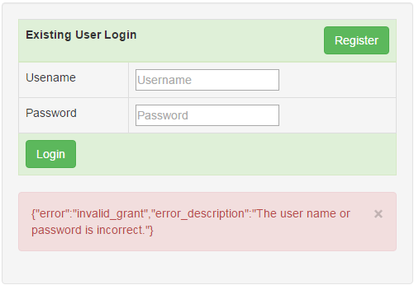   
  
  
  
Add a new HTML page to the **EmployeeService** project. Name it Login.html. Copy and paste the following HTML & jQuery code.

<!DOCTYPE html>

<html>

<head>

    <title></title>

    <meta charset="utf-8" />

    <link href="Content/bootstrap.min.css" rel="stylesheet" />

</head>

<body style="padding-top:20px">

    <div class="col-md-10 col-md-offset-1">

        <div class="well">

            <!--Table to capture username and password-->

            <table class="table table-bordered">

                <thead>

                    <tr class="success">

                        <th colspan="2">

                            Existing User Login

                            <a href="Register.html" class="btn btn-success pull-right">

                                Register

                            </a>

                        </th>

                    </tr>

                </thead>

                <tbody>

                    <tr>

                        <td>Usename</td>

                        <td>

                            <input type="text" id="txtUsername" placeholder="Username" />

                        </td>

                    </tr>

                    <tr>

                        <td>Password</td>

                        <td>

                            <input type="password" id="txtPassword"

                                   placeholder="Password" />

                        </td>

                    </tr>

                    <tr class="success">

                        <td colspan="2">

                            <input id="btnLogin" class="btn btn-success" type="button"

                                   value="Login" />

                        </td>

                    </tr>

                </tbody>

            </table>

            <!--Bootstrap alert to display error message if the login fails-->

            <div id="divError" class="alert alert-danger collapse">

                <a id="linkClose" href="#" class="close">&times;</a>

                <div id="divErrorText"></div>

            </div>

        </div>

    </div>

    <script src="Scripts/jquery-1.10.2.min.js"></script>

    <script type="text/javascript">

        $(document).ready(function () {

            $('#linkClose').click(function () {

                $('#divError').hide('fade');

            });

            $('#btnLogin').click(function () {

                $.ajax({

                    // Post username, password & the grant type to /token

                    url: '/token',

                    method: 'POST',

                    contentType: 'application/json',

                    data: {

                        username: $('#txtUsername').val(),

                        password: $('#txtPassword').val(),

                        grant_type: 'password'

                    },

                    // When the request completes successfully, save the

                    // access token in the browser session storage and

                    // redirect the user to Data.html page. We do not have

                    // this page yet. So please add it to the

                    // EmployeeService project before running it

                    success: function (response) {

                        sessionStorage.setItem("accessToken", response.access_token);

                        window.location.href = "Data.html";

                    },

                    // Display errors if any in the Bootstrap alert <div>

                    error: function (jqXHR) {

                        $('#divErrorText').text(jqXHR.responseText);

                        $('#divError').show('fade');

                    }

                });

            });

        });

    </script>

</body>

</html>

**Please note :**  
1. sessionStorage data is lost when the browser window is closed.  
2. To store an item in the browser session storage use setItem() method  
     **Example :** sessionStorage.setItem("accessToken", response.access_token)

3. To retrieve an item from the browser session storage use getItem() method  
     **Example :** sessionStorage.getItem("accessToken")  
4. To remove an item from the browser session storage use removeItem() method  
     **Example :** sessionStorage.removeItem('accessToken')  
  
On the **Register.html** page, we do not have Login button, which takes us to the Login page if the user is already registered. So please include Login button just below **"New User Registration"** text in the <th> element on Register.html page as shown below.

<thead>

    <tr class="success">

        <th colspan="2">

            New User Registration

            <a href="Login.html" class="btn btn-success pull-right">Login</a>

        </th>

    </tr>

</thead>

In our next video we will discuss implementing the Data.html page which retrieves data by calling the EmployeesController using the bearer token.